**Programming Fundamentals**

**Lab Report**

**Lab 06**



|  |  |
| --- | --- |
| Group Members Name & Reg #: | **Muhammad Haris Irfan**  **(FA18-BCE-090)** |
|  |  |
| Class | Programming Fundamentals CSC103 (**BCE-2B**) |
| Instructor’s Name | Dilshad Sabir |

**In Lab Tasks**

**Question no: 1**

Write a C program that takes three inputs (floating type) from user and find the minimum number and print it on screen.(Do not use min or max c function)

**Solution:**

In this Program I asked the user to give three floating point numbers and then compared all using if/else statement and printed the minimum number on screen, code is attached below.

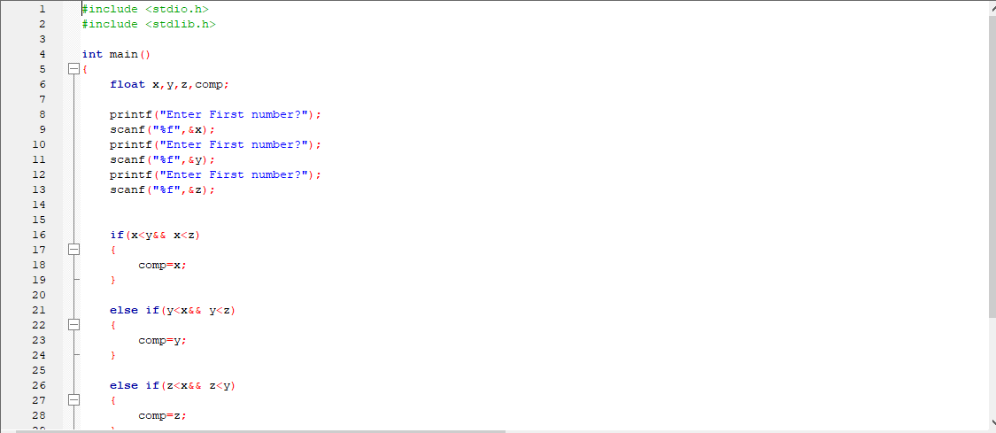

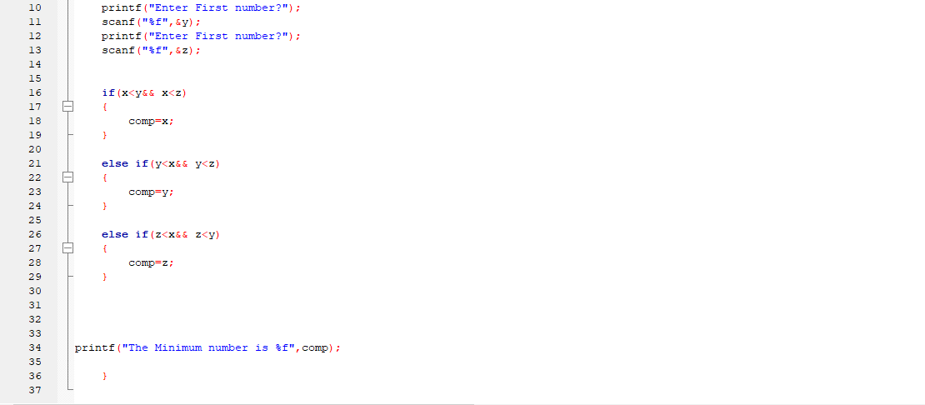

I tested the program for the value 4, 5 and 6 and it gave 4 as the lowest number.

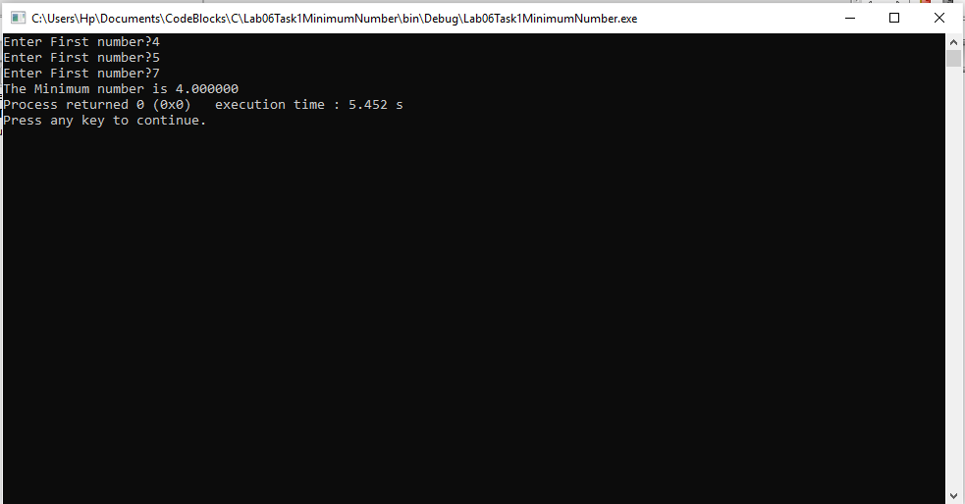

Hence, our program is correct.

-------------------------------

**Question no: 2(a)**

Write a C program that input value of 𝑛 and calculate the value of 𝑦 then print its value in main program on screen. Write separate functions to implement Functions.

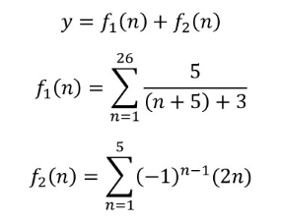

Solution

In this program I made two separate functions, and then added their sum, the code is attached below,

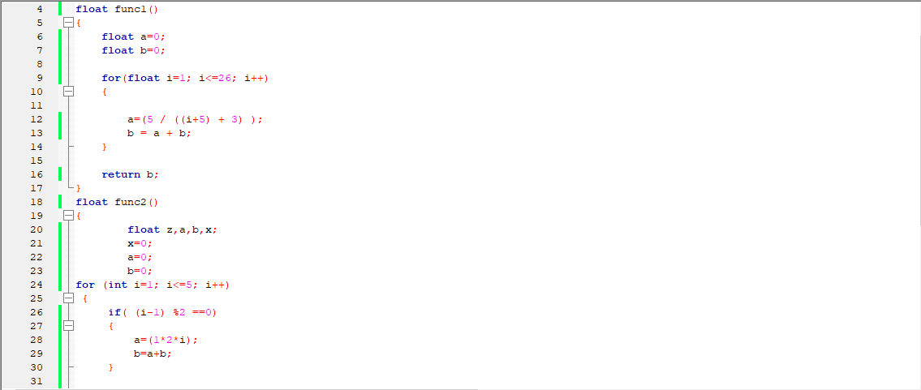

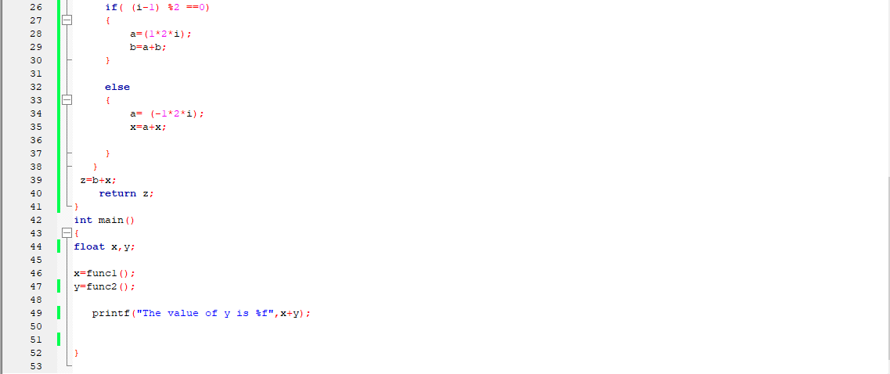

The value of the code is shown below,

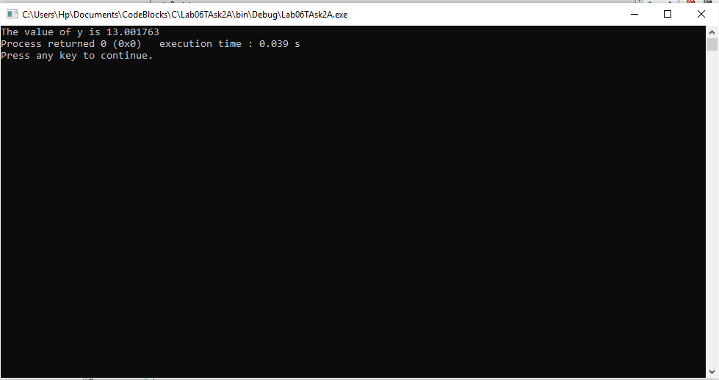

Hence, our code is correct.

-------------------------------

**Question no: 2(b)**

1. Modify the above program to calculate the value of 

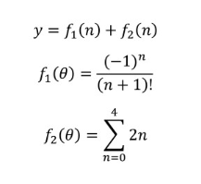

**Solution**

In this program I made two functions, then took a value n from the user then added the individual result of these programs and printed it, code is attached below.

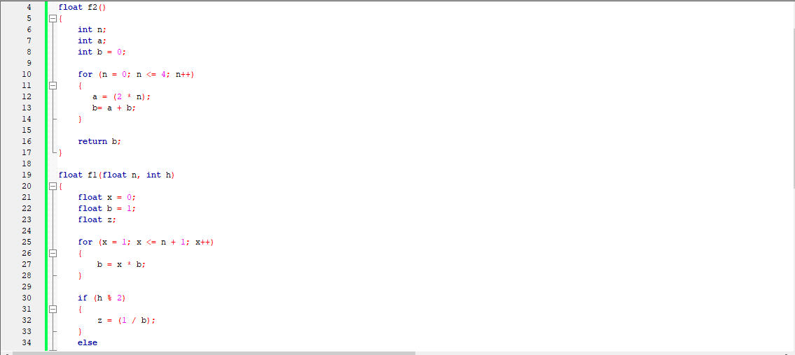

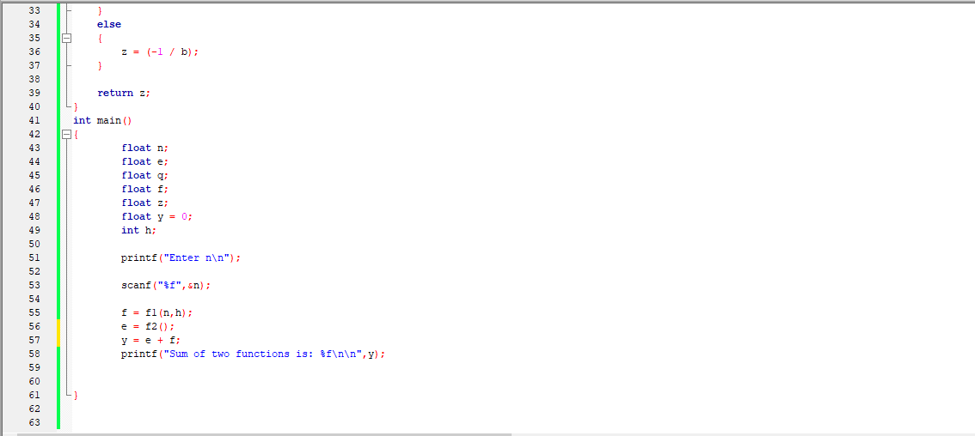

The result for value of n=123, is shown below.

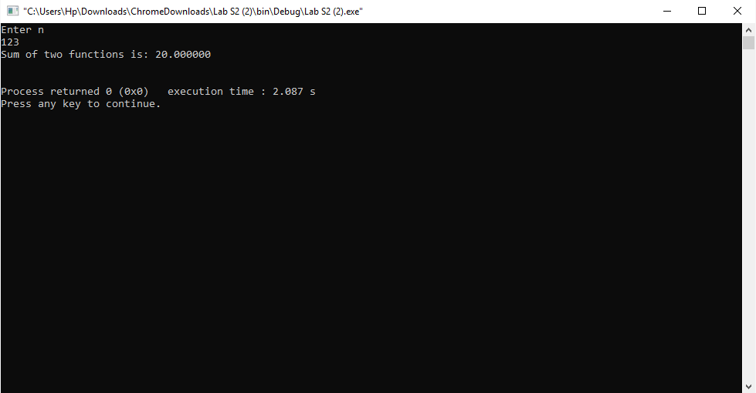

Hence, Our code is correct.

------------------------------

POST LAB

Question:

Write a C program that takes three inputs (floating type) from user and find the maximum number and print it on screen. (Do not use min or max c function)

Solution:

In this program I asked user to input three floating numbers and outputted the maximum number using if/else statement, code is attached below.

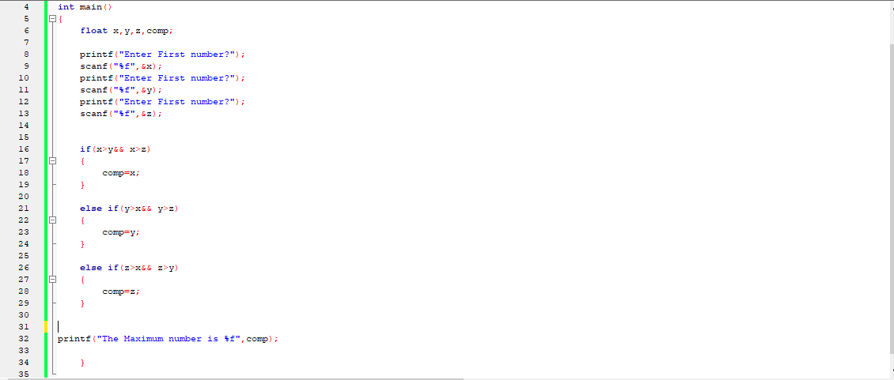

I tested the code for values 4,6, and 3 and it outputted 6 as the highest value.

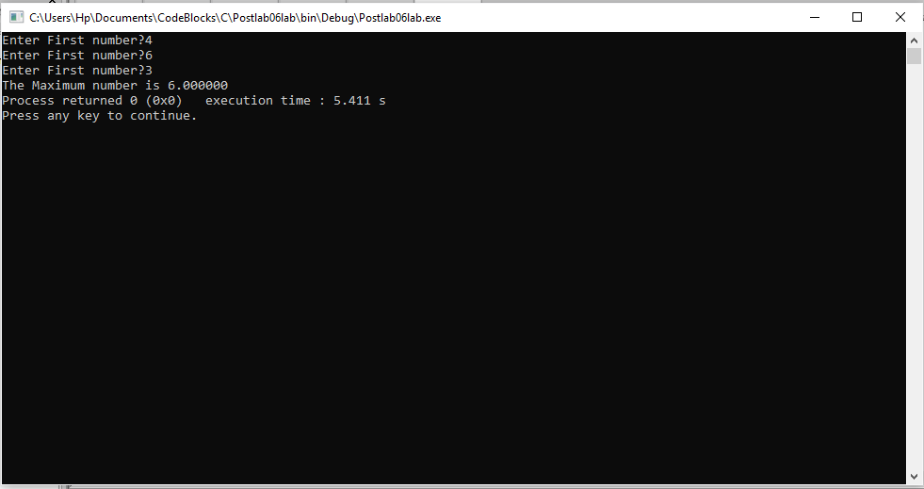

Hence, our code is correct.

-------------------------------

THE END